I was at my internship in Ireland, Cork from 3rd of May to 1st of June. I had the chance to be at this internship thanks to Obchodni Akademie s.r.o. and Erasmus + programme.
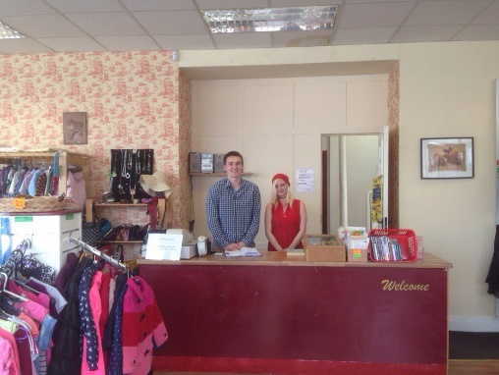
I was working in Twice Is Nice charity shop. This shop takes unnecessary things from people and sells them with price as they settle. A part of money goes to some charity companies. I did a lot of different. For example, every day was started from cleaning of the shop, then people brought us some donations during the whole day and we had to sort them. If there were clothes, we sort them by sizes and sex. If there were DVDs, we sort them by genres and categories, etc. Then we priced donations, looked at them and if they were good, we gave an expensive price. Always I had to help customers, because the shop was unusual and it wasnot easy to find what you needed
As for experience, it was my first job. I liked that and studied many new things. Now I know how to keep shop clear, how to speak with customers, how shops are working, the system of prices and a lot more.
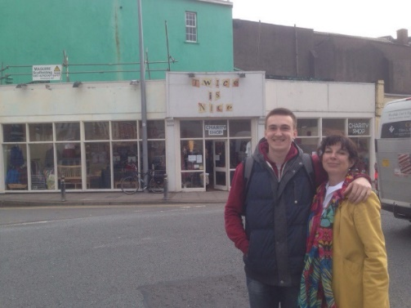
I improved my English as well. Boss often tries to talk to you and you must explain what do you think or what do you want. I learned many new words and started to speak faster. Also, I saw the difference between English and Irish accents. I lived in a small house but with a great family. There was just a mother and she always tried to speak with me, listen my stories and tell really long stories herself. It was funny and interesting. Food was normal, I wasn’t hungry and there was big choice. I am very glad that I have lived exactly with this family.
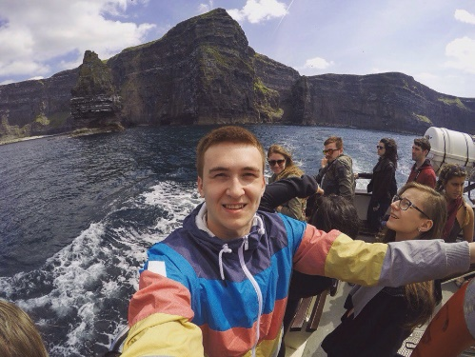
At the weekends and second parts of regular days we had a lot of free time. We could spend it as we wanted. We were walking in the city centre, shopping, going sightseeing, travelling to brilliant places like Cliffs of Moher and Jameson Whiskey Museum. I am really happy because of it.
Accomodation, food, buses, airplane and some pocket money were payed and given to us. Before the internship we had online English courses to be ready. It was helpful. Well, the whole trip to Ireland and the job was very informative and useful. I was surprised of beautiful Irish nature and city places and really glad to try myself at work. It was incredible time and I hope to repeat the internship next year.

